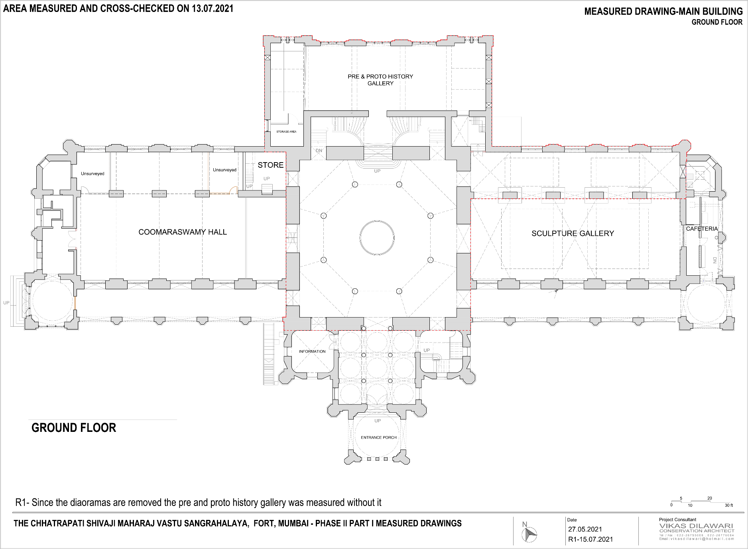

ENTRANCE FOYER

INDIAN SCULPTURE GALLERY

**SPACES FOR THE ANCIENT WORLD GALLERY PROJECT**

1649 x 1649 cm

ROTUNDA GALLERY